Day 30

Java throws keyword
The Java throws keyword is used to declare an exception. It gives an information to the programmer that there may occur an exception. So, it is better for the programmer to provide the exception handling code so that the normal flow of the program can be maintained.
Exception Handling is mainly used to handle the checked exceptions. If there occurs any unchecked exception such as NullPointerException, it is programmers' fault that he is not checking the code before it being used.

Syntax of Java throws
return_type method_name() throws exception_class_name{
//method code
}

Which exception should be declared?
Ans: Checked exception only, because:
- unchecked exception: under our control so we can correct our code.
- error: beyond our control. For example, we are unable to do anything if there occurs VirtualMachineError or StackOverflowError.

Advantage of Java throws keyword
Now Checked Exception can be propagated (forwarded in call stack).
It provides information to the caller of the method about the exception.

Java throws Example
Let's see the example of Java throws clause which describes that checked exceptions can be propagated by throws keyword.
Testthrows1.java
import java.io.IOException;
class Testthrows1{
void m()throws IOException{
throw new IOException("device error");//checked exception
}
void n()throws IOException{
m();
}
void p(){
try{
n();
}catch(Exception e){System.out.println("exception handled");}
}
public static void main(String args[]){
Testthrows1 obj=new Testthrows1();
obj.p();
System.out.println("normal flow...");
}
}

Rule: If we are calling a method that declares an exception, we must either caught or declare the exception.
There are two cases:
- Case 1: We have caught the exception i.e. we have handled the exception using try/catch block.
- Case 2: We have declared the exception i.e. specified throws keyword with the method.

Case 1: Handle Exception Using try-catch block
In case we handle the exception, the code will be executed fine whether exception occurs during the program or not.
Testthrows2.java
import java.io.*;
class M{
void method()throws IOException{
throw new IOException("device error");
}
}
public class Testthrows2{
public static void main(String args[]){
try{
M m=new M();
m.method();
}catch(Exception e){System.out.println("exception handled");}

System.out.println("normal flow...");
}
}

Case 2: Declare Exception
- In case we declare the exception, if exception does not occur, the code will be executed fine.
- In case we declare the exception and the exception occurs, it will be thrown at runtime because throws does not handle the exception.
Let's see examples for both the scenario.
A) If exception does not occur
Testthrows3.java
import java.io.*;
class M{
void method()throws IOException{
System.out.println("device operation performed");
}
}
class Testthrows3{
public static void main(String args[])throws IOException{//declare exception
M m=new M();
m.method();

System.out.println("normal flow...");
}
}

B) If exception occurs

Testthrows4.java
import java.io.*;
class M{
void method()throws IOException{
throw new IOException("device error");
}
}
class Testthrows4{
public static void main(String args[])throws IOException{//declare exception
M m=new M();
m.method();

System.out.println("normal flow...");
}
}

Difference between throw and throws in Java

The throw and throws is the concept of exception handling where the throw keyword throw the exception explicitly from a method or a block of code whereas the throws keyword is used in signature of the method.

There are many differences between throw and throws keywords. A list of differences between throw and throws are given below:

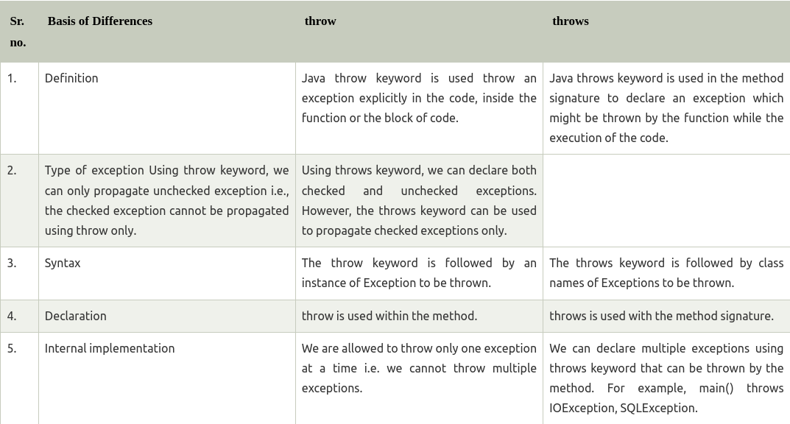

public class TestThrow {  //defining a method  public static void checkNum(int num) {  if (num < 1) {  throw new ArithmeticException("\nNumber is negative, cannot calculate square");  }  else {  System.out.println("Square of " + num + " is " + (num*num));  }  }  //main method  public static void main(String[] args) {  TestThrow obj = new TestThrow();  obj.checkNum(-3);  System.out.println("Rest of the code..");  }  } | public class TestThrows {  //defining a method  public static int divideNum(int m, int n) throws ArithmeticException {  int div = m / n;  return div;  }  //main method  public static void main(String[] args) {  TestThrows obj = new TestThrows();  try {  System.out.println(obj.divideNum(45, 0));  }  catch (ArithmeticException e){  System.out.println("\nNumber cannot be divided by 0");  }  System.out.println("Rest of the code..");  }  }
public class TestThrowAndThrows
{
// defining a user-defined method
// which throws ArithmeticException
static void method() throws ArithmeticException
{
System.out.println("Inside the method()");
throw new ArithmeticException("throwing ArithmeticException");
}
//main method
public static void main(String args[])
{
try
{
method();
}
catch(ArithmeticException e)
{
System.out.println("caught in main() method");
}
}
}

Difference between final, finally and finalize
The final, finally, and finalize are keywords in Java that are used in exception handling. Each of these keywords has a different functionality. The basic difference between final, finally and finalize is that the final is an access modifier, finally is the block in Exception Handling and finalize is the method of object class.
Along with this, there are many differences between final, finally and finalize. A list of differences between final, finally and finalize are given below:

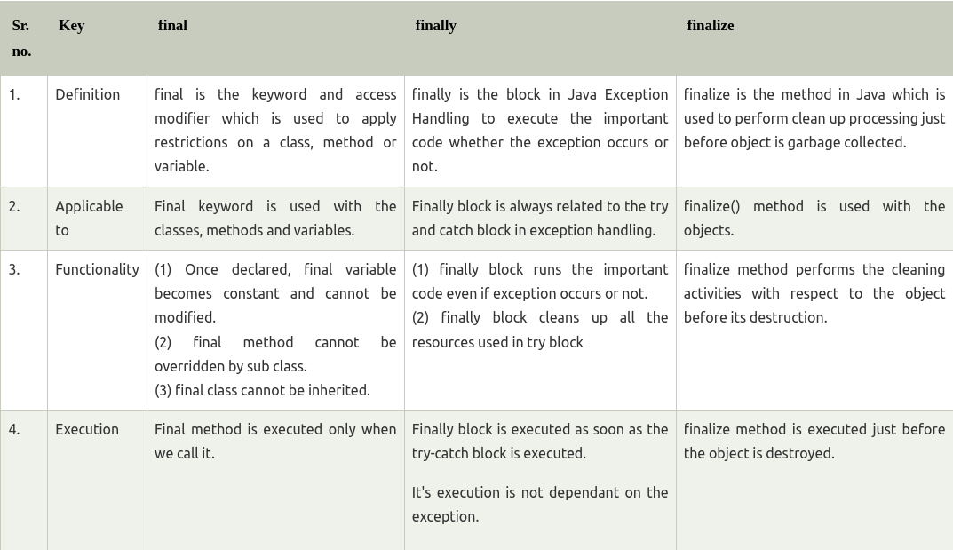

Java final Example
Let's consider the following example where we declare final variable age. Once declared it cannot be modified.
FinalExampleTest.java
public class FinalExampleTest {
//declaring final variable
final int age = 18;
void display() {

// reassigning value to age variable
// gives compile time error
age = 55;
}

public static void main(String[] args) {

FinalExampleTest obj = new FinalExampleTest();
// gives compile time error
obj.display();
}
}

In the above example, we have declared a variable final. Similarly, we can declare the methods and classes final using the final keyword.

Java finally Example
Let's see the below example where the Java code throws an exception and the catch block handles that exception. Later the finally block is executed after the try-catch block. Further, the rest of the code is also executed normally.
public class FinallyExample {  public static void main(String args[]){  try {  System.out.println("Inside try block");  // below code throws divide by zero exception  int data=25/0;  System.out.println(data);  }  // handles the Arithmetic Exception / Divide by zero exception  catch (ArithmeticException e){  System.out.println("Exception handled");  System.out.println(e);  }  // executes regardless of exception occurred or not  finally {  System.out.println("finally block is always executed");  }  System.out.println("rest of the code...");  }  } | public class FinalizeExample {  public static void main(String[] args)  {  FinalizeExample obj = new FinalizeExample();  // printing the hashcode  System.out.println("Hashcode is: " + obj.hashCode());  obj = null;  // calling the garbage collector using gc()  System.gc();  System.out.println("End of the garbage collection");  }  // defining the finalize method  protected void finalize()  {  System.out.println("Called the finalize() method");  }  }

